|  |  |
| --- | --- |
|  | **The Curse of Adam Cheng: A Study of Adam Effect on Hang Seng Index** |
|  |  |
| 10 MAY 2013  8:40pm – 9:05pm | MAFS 5130 Quantitative Analysis of Financial Time Series |
|  | Cheng Tak Sum 20074318  Fung Wing Hong, Derrick 20073417  Kwan Siu Tat, Tommy 09235921  Suen Pak Lim, Frank 09068483  Tsui Shing Hoi 09040003 |

**Table of Content**

1 Introduction………………………………………………………………………………………..3

1.1 What is Adam Effect?...…………………………………………………………………………...3

1.2 Historical Performance……………………………………………………………………………4

1.3 Literature Review…………………………………………………………………………………5

2 Data Analysis……………………………………………………………………………………...8

2.1 Data Description…………………………………………………………………………………..8

2.2 Dickey-Fuller Unit Root Test to Check Whether {rt} is Stationary………………………………9

2.3 Checking Serial Correlation of {rt}…………………………………………………………...…10

2.4 Checking ARCH Effect among {rt}……………………………………………………………...11

3 Methodology…………………………………………………………………………………......12

3.1 AR(p)-GARCH(m,s)…..…………………………………………………………………………12

3.2 AR(p)-GARCH(m,s) with Adam Effect on Both the Mean and Volatility Equation………...…..12

3.3 AR(p)-GARCH(m,s) with Adam Effect on the Mean Equation.…………………...……………13

3.4 AR(p)-GARCH(m,s) with Adam Effect on the Volatility Equation………...……………...……13

4 SAS Output…………………………………………………………………………….………...15

4.1 Model Fitting……...…..……………………………………………………………...………….15

4.2 AR(1,3,4)-GARCH(1,2)………………………………………………………….……………...16

4.3 AR(1,3,4)-GARCH(1,2) with Adam Effect on Both the Mean and Volatility Equation………...18

4.4 AR(1,3,4)-GARCH(1,2) with Adam Effect on the Mean Equation……………………………..20

4.5 AR(1,3,4)-GARCH(1,2) with Adam Effect on the Volatility Equation……………………….…21

5 Conclusion…………………………………………………………………………………….....23

6 Reference.…………………………………………………………………………………….....24

Appendix A – Source Data and SAS Program Codes………………..……………………………..…...25

**1 Introduction**

* 1. **What is Adam Effect?**

The Adam Effect, also called Ting Hai Effect or Chiu-Koon Effect, is a case of Behavioral Finance and an unusual stock phenomenon. The Adam effect is the sudden and unexplained drop in the stock market in the period when Adam Cheng Siu Chow’s drama series are broadcasted in Hong Kong.

*Figure 1.1: News about Adam Effect in the newspaper and magazine*



The Adam Effect was first mentioned in the media in early 90s. The name “Ting Hai” or “Crab Ting” was the name of the role played by Adam Cheng Siu Chow in the TV Drama Series *The Greed of Man* (大時代) in late 1992. During the broadcast in 1992, the Hang Seng Index slumped 12.7% for the whole period with maximum decline of about 20.1%. Since the occurrence of this unexplainable stock performance, investors started to blame the adverse effect caused by Adam Cheng’s drama series on the Hang Seng Index. Investors blamed that the Hang Seng Index would most probably decline when Adam’s Drama Series were broadcasted. Therefore, the Adam Effect has been established in the media and even occurred in broker research since 1992.

**1.2 Historical Performance**

In the past 21 years, nearly 70% of Adam Cheng’s TV series resulted in a down market. In general, the more tragic the TV series was, the worse the Hang Seng Index performed. We found that the Hang Seng Index always fell for some period of time, if not the whole period, during Adam’s TV drama series were broadcasted. The index drop ranged from 0.1% to 25% with average drop of 4.1%

*Figure 1.2: Chart of HSI performance during Adam Cheng’s TV Drama Series in Hong Kong (1992-2012)*

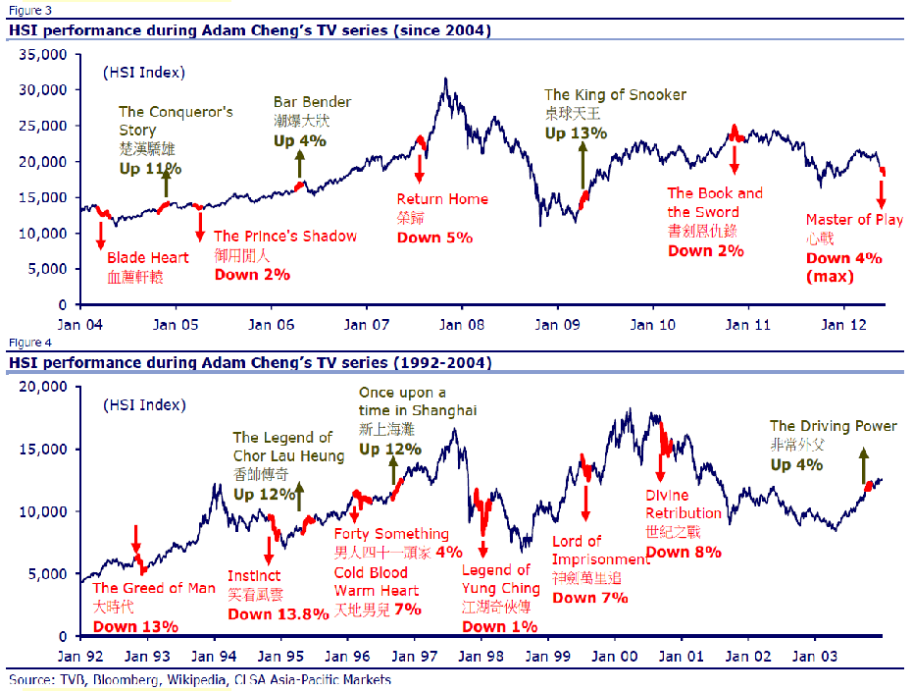

In addition, most of the effects lasted for around 60% of the period when the drama series were broadcasted. In order words, HSI usually dropped in the first 60% of episodes. Figure 1.3 shows some examples of HSI performance during different drama series

*Figure 1.3: Examples of HSI performance during broadcasts*

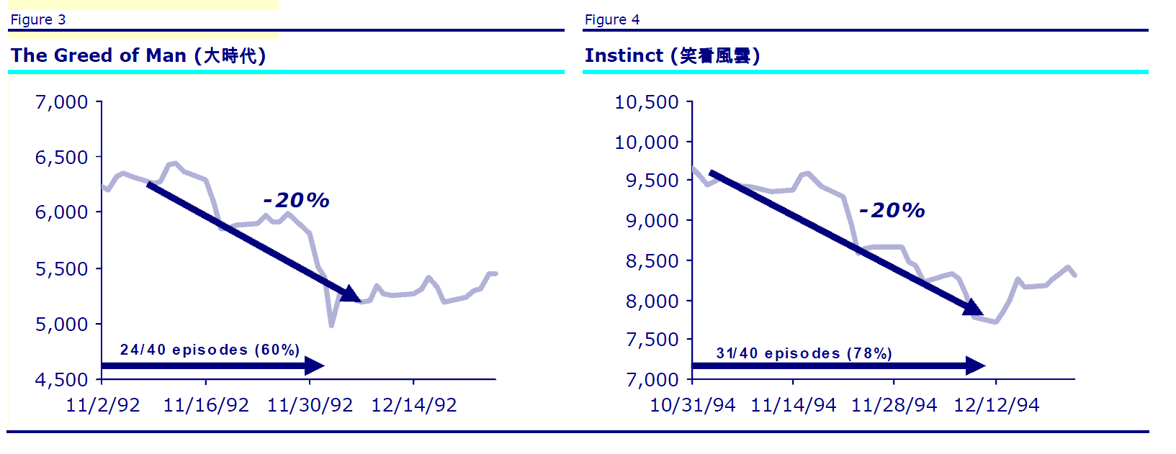

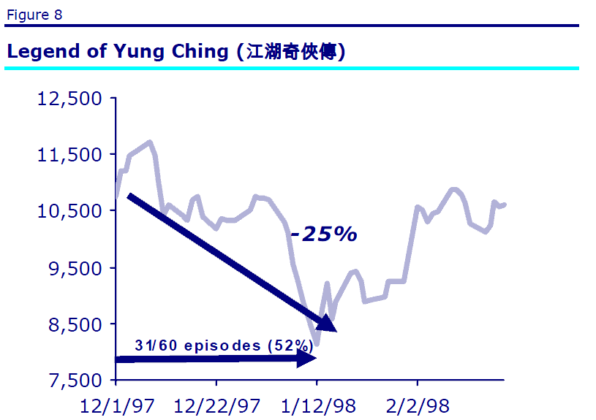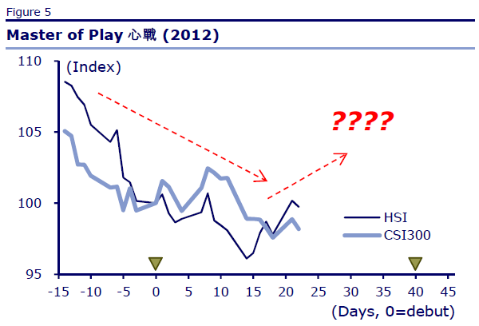

**1.3 Literature Review**

Although the Adam Effect is seems to be mysterious and ridiculous in a certain sense, it led several formal financial researches conducted by brokerage and investment firm called CLSA Asia-Pacific Markets Limited. Gabriel Chan & Kenny Lau (2004) did a regression analysis on the three-month market upside potential given particular percentage declines of the HSI for each Adam’s TV series broadcasted. The object of the investigation is to find out the percent of market rebounds before the series ends. Figure 1.4 shows the regression analysis and the regression equation below:

*% Rebound =* -0.66 * (*max % decline during the show*) + 7.25%

The coefficient of the determination R-square is 0.5 which is not so bad. They also used this equation to predict the HSI three-month rebound target to 16.8%.

*Figure 1.4: regression analysis*

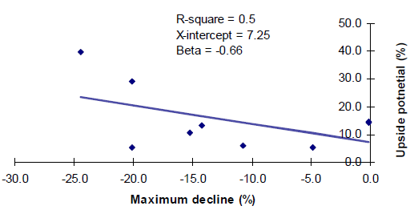

A revisit was done by another two analysts, Man Ho Lam & Francis Cheung (2012). They further looked at the types of the dramas and then added a new characteristic “tragic score” from -10 (most tragic) to +10 (happiest). Moreover, the TV rating point was taken into consideration in the research. They performed a regression analysis on the percentage change of the HSI given the product of the Tragic score and the TV rating for each Adam’s TV series broadcasted. Figure 1.5 shows the regression analysis and the regression equation below:

%HSIAdam = 0.0308*(Tragic score)*(TV rating) - 1.5216%

The coefficient of the determination R-square is 0.58 which is not so bad.

*Figure 1.5: regression analysis*

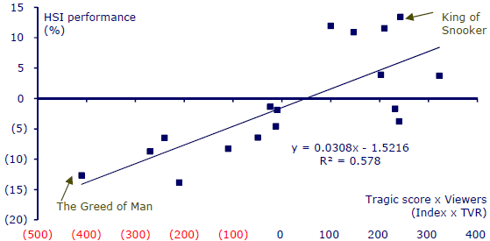

One more discovery is the Adam Effect on TVB share performance (0511.HK). Figure 1.6 shows the price of TVB share. Figure 1.7 shows the regression analysis on TVB share performance given the TV rating for each Adam’s TV series broadcasted.

*Figure 1.6 price of TVB share*

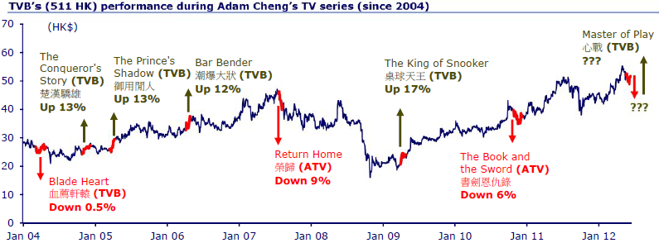

*Figure 1.7 regression analysis*

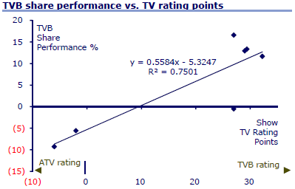

**2 Data Analysis**

***2.1 Data Description***

The Adam Effect became well-known since the broadcast of the TV drama series “The Greed of Man (大時代)” in 1992. Hence, we study the log return of HSI between the period of 1 January 1992 to 31 March 2013, which consists of 5250 observations in total. During such period, Adam Cheng had 18 TV drama series being broadcasted in Hong Kong (Table 2.1), which correspond to 562 trading days. We ignore Adam Cheng’s TV drama series being broadcasted in the Mainland and overseas because we are only interested in studying the Adam Effect on HSI, but not other Mainland and overseas index.

*Table 2.1: Summary of Adam Cheng’s TV Drama Series in Hong Kong*

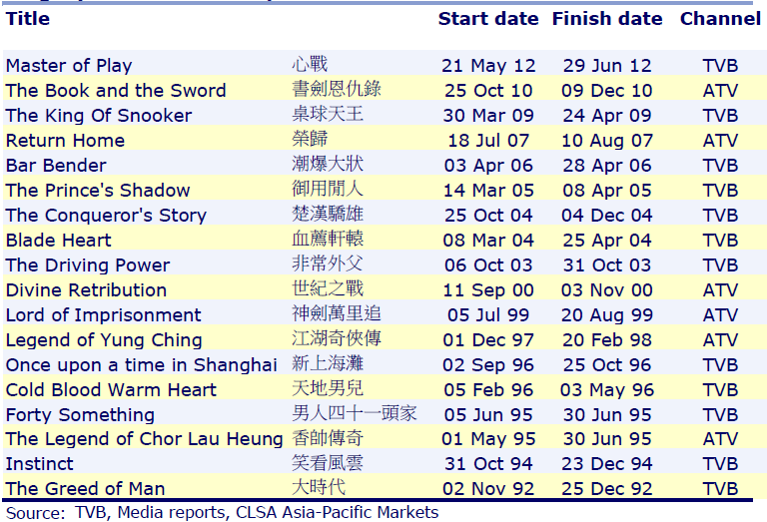

Based on the above, we extract 5250 observations of daily HSI log-returns from 1 January 1992 to 31 March 2013. A summary of the data is stated in Table 2.2.

*Table 2.2: Summary of Data Extracted from 1 January 1992 to 31 March 2013*



As noted from Table 2.2, the average log-return of HSI (i.e. rt) when Adam’s TV drama series were broadcasted was negative. However, with the large magnitude of volatility (i.e. rt2), it is too early to conclude whether Adam Effect has negative impact on rt. It is also interesting to note that the average rt2 was 17.8% higher than normal (i.e. 0.0344%/0.0292%) when Adam’s TV drama series were broadcasted. It is a positive indicator that we could apply more sophisticated and robust time series model to investigate whether the Adam Effect would decrease log-return rt and increase volatility σt2.

***2.2 Dickey-Fuller Unit Root Test to Check Whether {rt} is Stationary***

The foundation of time series analysis is stationarity. Hence, we first check whether the average log-return series of HSI {rt} is stationary by the Dickey-Fuller Unit Root Test before applying any time series model to {rt}. The test results are presented in Table 2.3.

*Table 2.3: Dickey-Fuller Unit Root Test Results on {rt}*

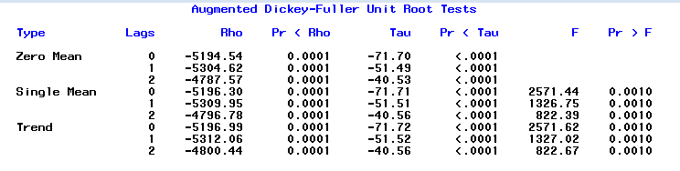

As noted from Table 2.3, the Zero Mean, Single Mean and Trend models are specified with their corresponding testing results with lags 0 to 3. Since all the p-values in Table 2.3 are smaller than 0.0001, we conclude that {rt} is stationary at 5% significance level.

***2.3 Checking Serial Correlation of {rt}***

In order to determine what time series model is suitable for {rt}, we have calculated the sample autocorrelation function (“ACF”) of {rt}, which is presented in Table 2.4.

*Table 2.4: Sample Autocorrelation Function (“ACF”) of {rt}*

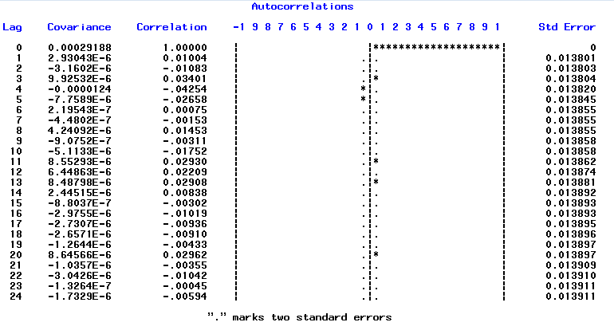

Based on Table 2.4, it is hard to conclude whether there are any statistically significant serial correlations among {rt}. Hence, we apply the Joint test (Ljung-Box statistics) to the autocorrelations with testing results presented in Table 2.5.

*Table 2.5: Autocorrelation Check for White Noise among {rt}*

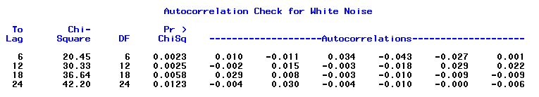

Based on Table 2.5, the p-values of Ljung-Box statistics for all lags are smaller than 0.05. Hence, we conclude that serial correlation exists among {rt} at 5% significance level. It is an indicator that the time series model we apply to {rt} should incorporate AR components.

***2.4 Checking ARCH Effect among {rt}***

In order to determine whether there is any ARCH effect among {rt}, we carry out the Ljung-Box statistics (test for the m-lags of ACF of {at2} are 0) and the Lagrange Multiplier tests to the {at2} series. The testing results are stated in Table 2.6.

*Table 2.6: Testing Results of ARCH Effect among {rt}*

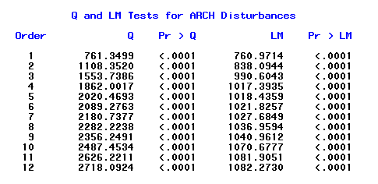

Based on table 2.6, all the p-values of Q statistics and Lagrange Multiplier tests are less than 0.0001. Hence, we conclude that there is ARCH effect among {rt} at 5% significance level. It is an indicator that the time series model we apply to {rt} should incorporate ARCH components.

**3 Methodology**

***3.1 AR(p)-GARCH(m,s)***

Before taking into account of the Adam Effect, we first fit the {rt} series to a suitable time series model. As indicated in s2.4 and s2.5, significant serial correlation and ARCH effect exist among {rt}. Hence, we begin with the AR(p)-GARCH(m,s) model as stated below:

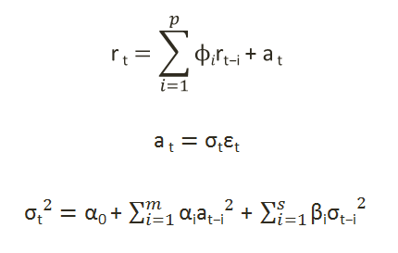

The model building procedures to determine p, m and s as well as the model fitting results and validation are described in s4.2.

***3.2 AR(p)-GARCH(m,s) with Adam Effect on Both the Mean and Volatility Equation***

If we suspect that the Adam Effect has negative impact on rt and positive impact on σt2, we could modify the AR(p)-GARCH(m,s) model obtained in s3.1 to incorporate the Adam Effect as follows:

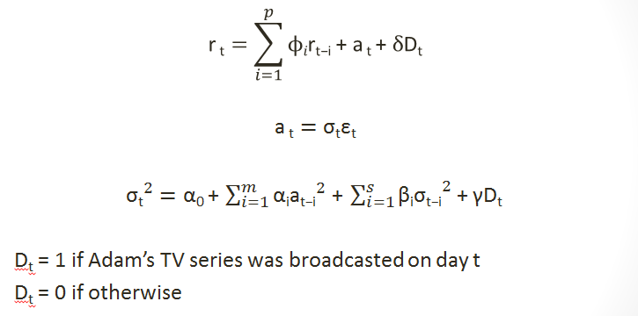

If the Adam Effect has negative impact on rt and positive impact on σt2, we would expect the estimated parameter δ is statistically significant and negative, while the estimated parameter γ is statistically significant and positive. Otherwise, we would further test the models prescribed in s3.3 and s3.4. The model fitting results and validation are described in s4.3.

***3.3 AR(p)-GARCH(m,s) with Adam Effect on the Mean Equation***

If we suspect that the Adam Effect only has negative impact on rt but no impact on σt2, we could modify the AR(p)-GARCH(m,s) model obtained in s3.1 to incorporate the Adam Effect as follows:

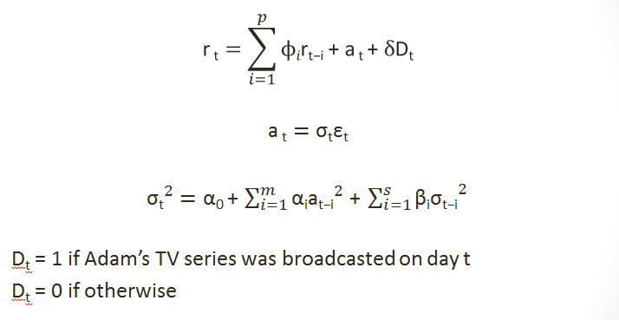

If the Adam Effect has negative impact on rt, we would expect the estimated parameter δ is statistically significant and negative. Otherwise, we have to conclude that the Adam Effect has no negative impact on rt. The model fitting results and validation are described in s4.4.

***3.4 AR(p)-GARCH(m,s) with Adam Effect on the Volatility Equation***

If we suspect that the Adam Effect only has positive impact on σt2 but no impact on rt, we could modify the AR(p)-GARCH(m,s) model obtained in s3.1 to incorporate the Adam Effect as follows:

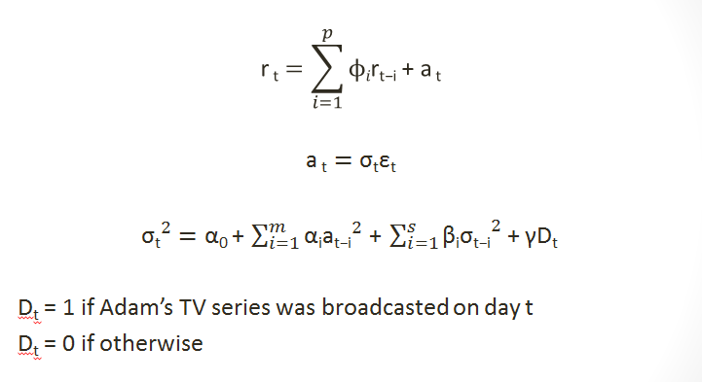

If the Adam Effect has positive impact on σt2, we would expect the estimated parameter γ is statistically significant and positive. Otherwise, we have to conclude that the Adam Effect has no positive impact on σt2. The model fitting results and validation are described in s4.5.

**4 SAS Output**

***4.1 Model Fitting***

Before running any regression to test Adam Effect, we have to find a suitable model for it first. Since there is no formal test or indicator for AR-GARCH model, we tried to get some intuition by testing the data from the AR(6)-GARCH(4,4) and tried fitting the data one by one. It turned out that AR(4)-GARCH(1,2) is the only valid model which suits our data and at same time produce white noise residuals. Below is the result:

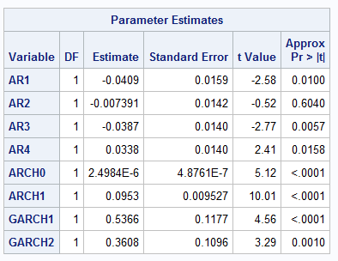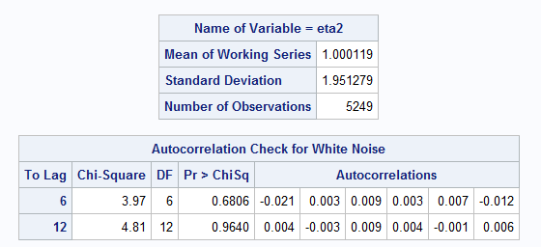

We can observe that by performing Ljung-Box test, the P-value is very high which indicates that the residuals are white noise and the model is fine. However, we can see from the regression table that the coefficient of AR2 is insignificant. As a result, we took away AR2 from the model and re-run the regression. The result will be shown in s4.2

***4.2 AR(1,3,4)-GARCH(1,2)***

First we tested the ordinary ARGARCH model to see if there is any meaningful result. Below are the model and the result:

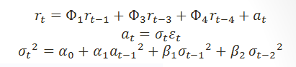

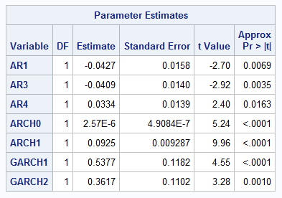

For the GARCH model, all of the coefficients give a significant p-value, which suggest that we should keep all the terms in the GARCH model.

Before claiming that the model is valid, we have to check whether the assumption is fulfilled by our model. The most important one is the white-noise assumption of the term $εt$. In this regard, we performed Ljung-Box test on $εt$ with results in the following table.

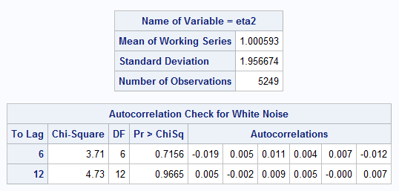

The above table shows that for the Lag-6 and Lag-12 autocorrelations statistics are all insignificant and the P-value is quite large. We can conclude that the white-noise assumption to be valid with confidence and further features can be built based on this AR(4)-GARCH(1,2) model to test for the Adam’s effect.

***4.3 AR(1,3,4)-GARCH(1,2) with Adam Effect on Both the Mean and Volatility Equation***

We then tried to evaluate the significance of Adam Effect on both mean and volatility:

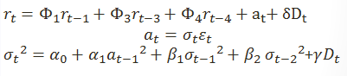

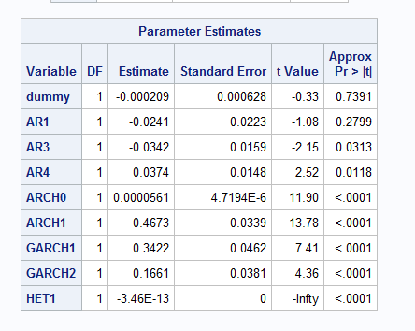

In order to test whether the Adam’s effect has influence on the Hang Seng Index, we tried to incorporate the Adam’s data into the auto-regression model.

Now we added a dummy variable into both the AR model and the GARCH model respectively. The dummy variable takes the value of 1 when Adam’s drama/ movie are being broadcasted on that trading day and 0 with the absent of Adam on air.

From the result shown above, the “dummy” term is actually the dummy variable in the AR model. It gives us an insignificant result and therefore we should drop that item.

For the dummy variable in the GARCH model, it is represented by the “HET1” term in the SAS output. Although it gives us a very significant outcome, it is prone to error for two reasons. First the “dummy” term will be dropped under a new regression model. This may affect the P-value of “HET1” term. Second, we still have to test for the white-noise assumption in the model.

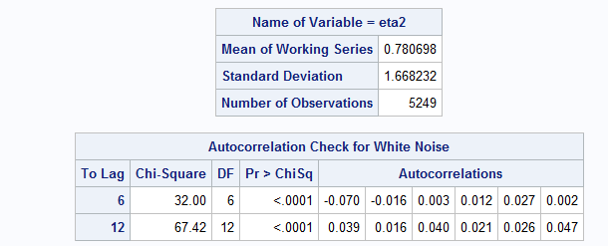

With the Ljung-Box test for the residual term, we know that the P-values of the autoregression statistics with Lag-6 and Lag-12 are statistically significant. It implies that the statistics are different from zero, suggesting correlation between the residual terms. Thus, the white-noise assumption is rejected here and the model should be scrapped.

***4.4 AR(1,3,4)-GARCH(1,2) with Adam Effect on the Mean Equation***

We then turned to determine if Adam effect influences only the mean but not the volatility. We added a dummy variable on the AR model. The model we used is as the following:

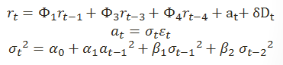

Below is the SAS output:

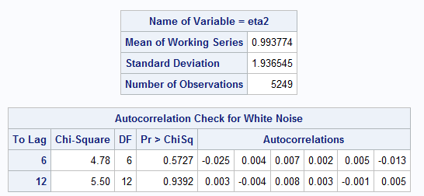

We first tested the correctness of the model by examining if the noise is white noise using Ljung-box Test. The P-values are large (0.5727 & 0.9392) thus we can conclude that the noise in this model is white noise and it justifies the correctness of the model.

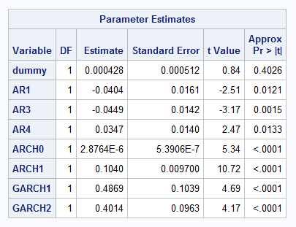

However, looking at the result of the regression, we can find that the dummy variable is highly insignificant as the P-value is very large (0.4026) despite the fact all other coefficients are significant. We then can conclude that the influence of Adam Effect on the mean alone is not statistically significant.

***4.5 AR(1,3,4)-GARCH(1,2) with Adam Effect on the Volatility Equation***

In the end, we tried to examine the influence of Adam Effect on the variance alone. The model we used and the result are as following:

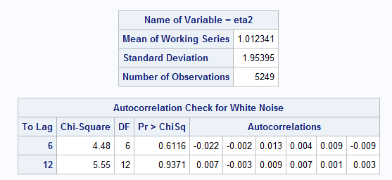

Again, we ran the Ljung-box test and the P-value was 0.7156 & 0.9665 for lag 6 and lag 12 respectively, which indicated that the test failed to reject the hypothesis of existence of auto-correlation. We can then conclude that the noise is White-noise and believe that the model is correct.

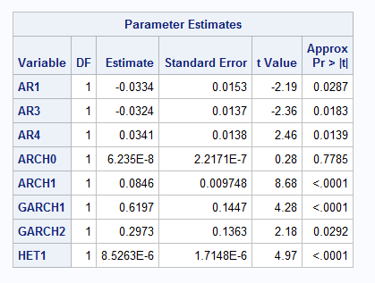

After justifying the correctness of the model, we can then look at the result of the regression. We can see that all the coefficients are statistically significant including the dummy variable. Combining the fact that the model is correct, we can conclude that Adam Effect makes certain influence to the variance of HSI return rate.

Note that the coefficient of the dummy variable is very small (8.5*10-6). At the first glance it might be tempting to think the effect is minimal. However, knowing that the returns we used were daily returns so the magnitudes of them were originally very small too. As a result, it is reasonable that the coefficient exhibits a small value.

**5 Conclusion**

In this project, we firstly found out the model AR(4)-GARCH(1,2) for the HSI. Secondly, we tested the Adam effect on both mean and volatility of the log-return in the same time. We found that they are both statistical insignificant. Thirdly, we tested the Adam effect on the mean of the log-return only. We still found that it is still statistical insignificant. Finally, we tested the Adam effect on the volatility of the log-return only. It is statistical significant. Based on these result, we conclude that the Adam effect actually valid on volatility of the log-return only.

**6 Reference**

1. Gabriel Chan & Kenny Lau, *Market Outlook: Adam Cheng Effect*, CLSA Asia-Pacific Markets, Hong Kong (30/3/2004)
2. Man Ho Lam & Francis Cheung, *Slice of life: Mind war*, CLSA Asia-Pacific Markets, Hong Kong (13/6/2012)

**Appendix A – Source Data and SAS Program Codes**

Source Data



SAS Program Codes

/*Input Data*/

**data** adam;

input date $ adj_close log_return_rt dummy log_return_square;

cards;

3/28/2013 22299.63 -0.007380444 0 0.0000544709

3/27/2013 22464.82 0.006867114 0 0.0000471573

3/26/2013 22311.08 0.002689723 0 0.0000072346

.

.

.

;

/*Find ACF, PACF, and Perform Unit-Root Test*/

**proc** **arima** data=adam;

identify var=log_return_rt stationarity=(adf);

**run**;

/*Test ARCH Effect*/

**proc** **autoreg** data=adam;

model log_return_rt = / archtest;

run;

/*test without dummies*/

**proc** **autoreg** data = adam;

/* check AR 1 2 3 4*/

model log_return_rt=/ noint nlag=(**1** **3** **4**) archtest

garch=(q=**1**, p=**2**) method=ml;

output out=r r=yresid cev=v predicted=p;

run;

/*test for both mean & variance*/

**proc** **autoreg** data = adam;

/* check AR 1 2 3 4*/

model log_return_rt=dummy/ noint nlag=(**1** **3** **4**) archtest

garch=(q=**1**, p=**2**) method=ml;

hetero dummy;

output out=r r=yresid cev=v predicted=p;

run;

/*test for mean only*/

**proc** **autoreg** data = adam;

/* check AR 1 2 3 4*/

model log_return_rt=dummy/ noint nlag=(**1** **3** **4**) archtest

garch=(q=**1**, p=**2**) method=ml;

output out=r r=yresid cev=v predicted=p;

run;

/*test for variance only*/

**proc** **autoreg** data = adam;

/* check AR 1 2 3 4*/

model log_return_rt=/ noint nlag=(**1** **3** **4**) archtest

garch=(q=**1**, p=**2**) method=ml;

hetero dummy;

output out=r r=yresid cev=v predicted=p;

**run**;